Manual de godot

Tilemap: <https://youtu.be/0Q2t_oHzZFA>

<https://opengameart.org/content/pixelart-platform-tileset>

<https://opengameart.org/content/tiny-16-basic>

<https://opengameart.org/content/pixel-man>

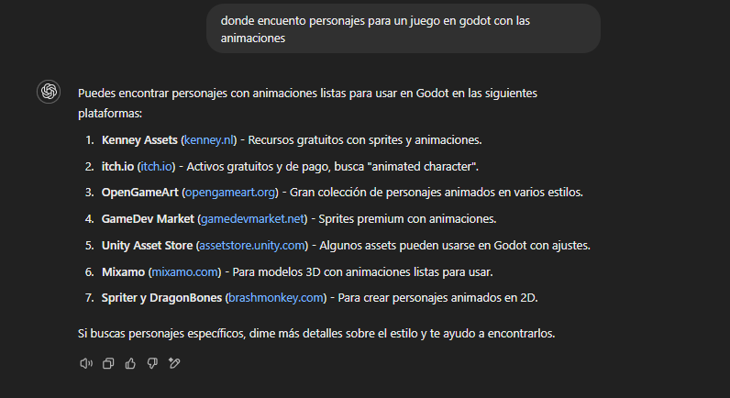

<https://opengameart.org/content/man-walking-animation>

<https://opengameart.org/content/walking-boy>

<https://opengameart.org/content/attack-animation-for-16x18-rpg-base-sprites>

<https://opengameart.org/content/the-boss>

<https://opengameart.org/content/modern-houses-tileset-topdown>

<https://opengameart.org/content/mini-gun-pack-1>

<https://opengameart.org/content/lpc-dungeon-elements>

<https://www.gamedevmarket.net/asset/tiny-tiny-heroes-animals>

<https://www.gamedevmarket.net/asset/safety-deposit-box>

<https://free-game-assets.itch.io/free-gangster-pixel-character-sprite-sheets-pack>

<https://www.kenney.nl/assets/rpg-urban-pack>

<https://opengameart.org/content/oldman2>

<https://youtu.be/g9eqGhus59Q?si=vhgFxzvjvlsfvByK>

VIDEO AYUDA

<https://www.youtube.com/watch?v=lO7veY5urHU>

MOVIMIENTO

https://www.youtube.com/watch?v=6hj6PwndLJE

WEAPON

<https://youtu.be/ANuCGdakZXs?si=rhmRhYcTQSdhxUkw>

PAGUINA AYUDA:

<https://youtu.be/S_uKxCOa3DM?si=7lybMYSJo7amn44c>

ITEM RADOM:

<https://youtu.be/C_f4Dmzvx34?si=Nc_RrBUoMM3-d--Q>

<https://grafxkid.itch.io/sprite-pack-2>

<https://bdragon1727.itch.io/free-trap-platformer>

<https://free-game-assets.itch.io/power-station-free-tileset-pixel-art>

https://craftpix.net/freebies/free-shinobi-sprites-pixel-art/

<https://craftpix.net/freebies/free-townspeople-cyberpunk-pixel-art/>

<https://craftpix.net/freebies/free-exclusion-zone-tileset-pixel-art/>

<https://craftpix.net/freebies/free-truck-constructor-pixel-art/>

<https://www.youtube.com/watch?v=UvAwdMlCNzw>

monedas

https://www.youtube.com/watch?v=_3LWmPAiGl0

<https://www.youtube.com/watch?v=_3LWmPAiGl0&t=634s>

resolución

<https://docs.godotengine.org/es/4.x/tutorials/rendering/multiple_resolutions.html>

<https://pt.fonts2u.com/pixel-operator-8-bold.fonte> fuente monedas

<https://docs.google.com/document/d/1lHhf1iRYgEd7vDLNS5U93WqZcpMIpZymAb57LON-jRQ/edit?tab=t.0> documentacion

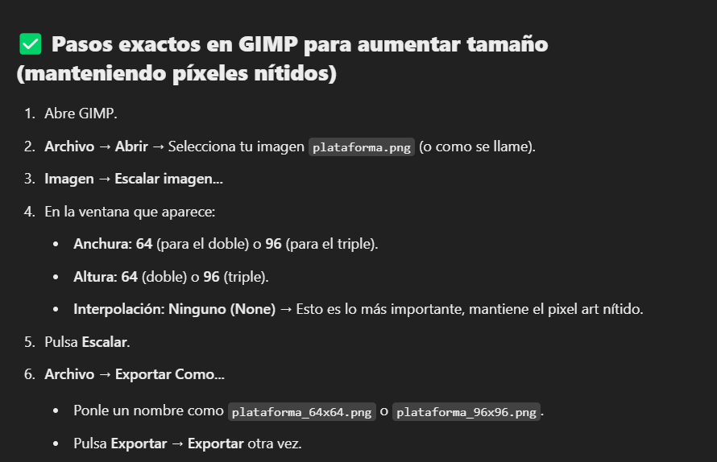

<https://free-game-assets.itch.io/free-city-backgrounds-pixel-art> fondo